**About Next.js**

**“Author : TianZhe”**

**Overview about Next.js**

-What is Next js?

Next.js is a React front-end framework that lets you optimize performance.

Next.js is used by full-stack developers to build reactive websites as it requires a good understanding of both client-side React and server-side architectures.

-What are advantages?

Next.js has some advantages.

1. ****Server Side Rendering(SSR).****

SSR allows the server to access all required data and process the JavaScript together to render the page. Then, the page is sent back in its entirety to the browser and immediately rendered. SSR allows webpages to load in a fraction of the time and increases user experience with added responsiveness.

1. ****Search Engine Optimization (SEO).****

  Using SSR also gives you an edge on SEO, which helps your site show up higher on search engine results pages. SSR makes websites rank better for SEO because they load faster and more of the site content can be scanned by SEO trackers.

.

1. ****Automatic Routing****

No need to configure any url for routing. files are to be placed in pages folder. All urls will be mapped to file system. Customization can be done.

The main advantage of Next.js is the built-in SSR support for increased performance and SEO.

Server-side rendering works by ****altering the request flow**** of the React application such that all components except the client send their info to the server.

With all info on the server, it can pre-render the HTML of the page. The client can send a single request to the server and receive the full HTML page rather than requesting each component individually with ****client-side rendering****.

From below figures, you can see clearly about Client-Side-Rendering and Server-Side-Rendering.

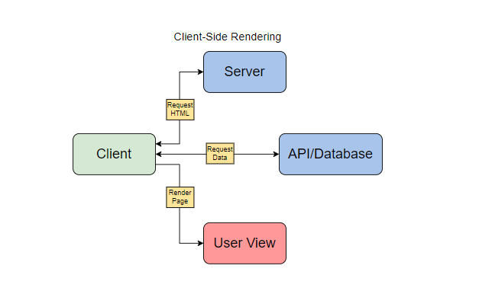

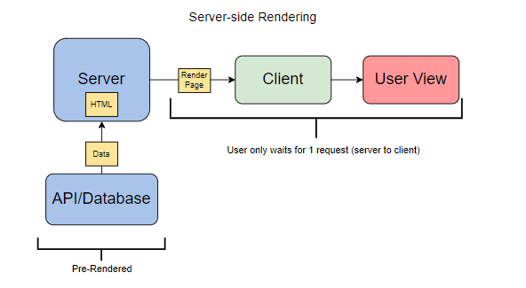

So generally, Next.js apps load considerably faster than React apps due to server-side rendering and client-side rendering.

-When to use Next.js

Next.js is best suited for making an optimized landing or homepage as well as any other pages that rely on organic search traffic. These pages will see the most benefit from SEO improvements of Next.js.

Next.js is also better for websites than web apps as SSR allows it to have the same performance regardless of the device the client is using.

But we can’t always use Next.js.

Next.js is less ideal for creating web applications or secured applications that require authentication because these do not benefit server-side rendering.

**How to create Next.js project**

We can install Next.js with Node. Enter npx create-next-app <app-name> into your command prompt.At this time, node should be higher than version 12.22.

For example



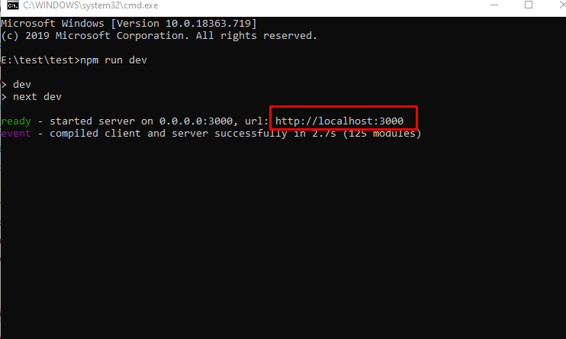

This allows you to start your new application in different modes:

Dev: starts Next.js in development mode.

Start: starts Next.js in production mode.

Build: builds your Next.js app for production. Regardless of which method you choose, this will generate the basic Next.js application template we saw earlier.

After installed successfully, Enter npm run dev into your command prompt.

If you run app using next dev, you’ll see the default Next.js page on http://localhost:3000.

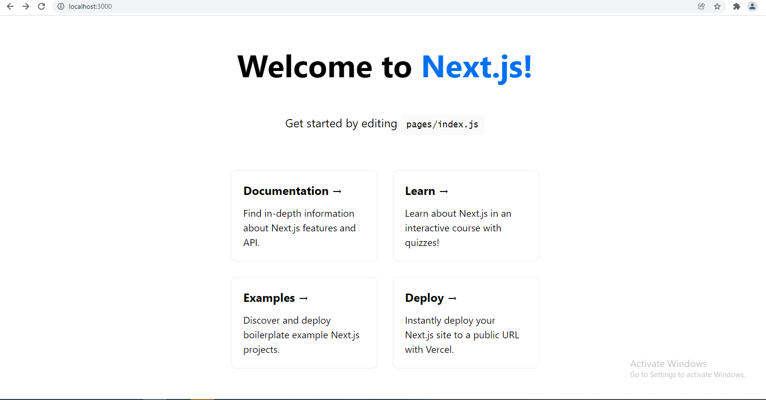

Then we can see project structure now.

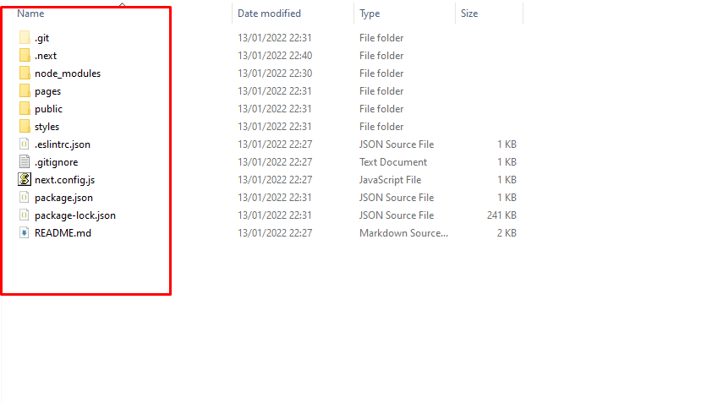

Components are saved in pages directory.

As I mentioned, we can access pages without config file because Automatic Routing works.

Next.js uses file system based router like React.

Whenever we add any page to pages directory, it is automatically available via url.

Following are the rules of this router.

**Index Routes:**

An index.js file present in a folder maps to root of directory. For example

pages/index.js maps to '/'.

pages/posts/index.js maps to '/posts'.

**Nested Routes:**

Any nested folder structure in pages directory because router url automatically.

For example

pages/settings/dashboard/about.js maps to '/settings/dashboard/about'.

pages/posts/first.js maps to '/posts/first'.

**Dynamic Routes:**

We can use named parameter as well to match url.

Use brackets for the same.

pages/posts/[id].js maps to '/posts/:id' where we can use URL like '/posts/1'.

Next.JS allows to link pages on client side using Link React component.

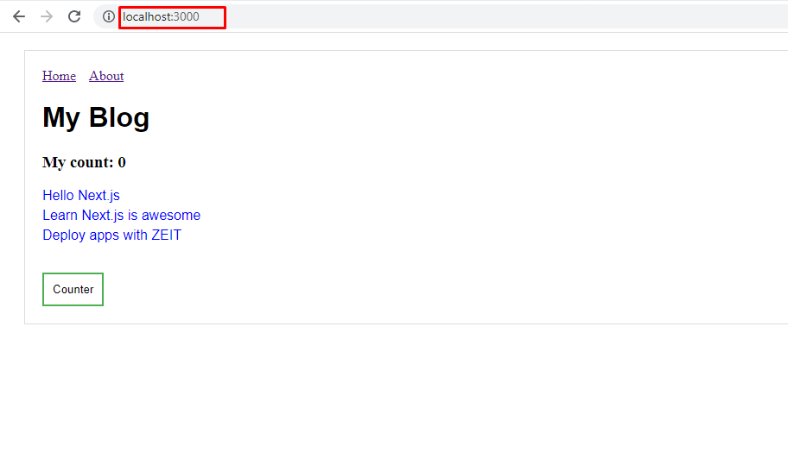

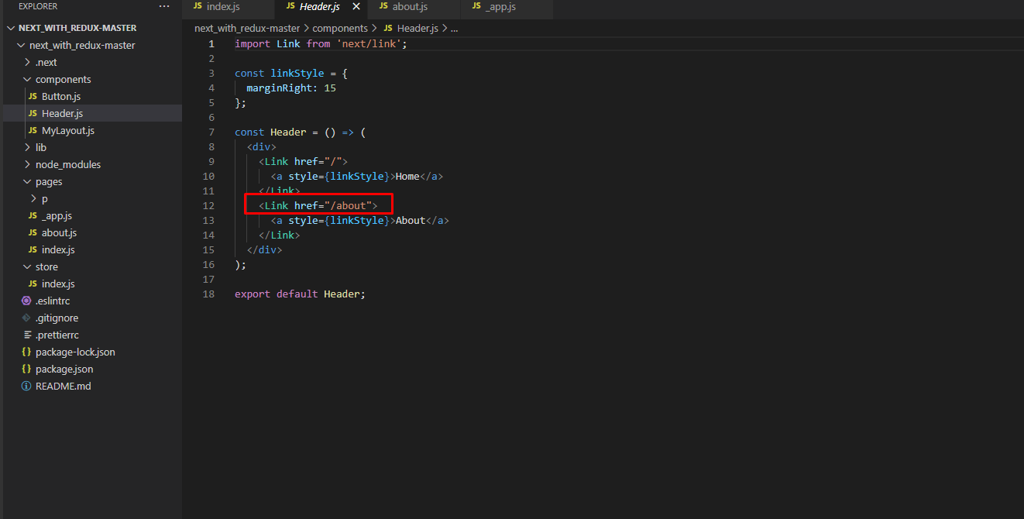

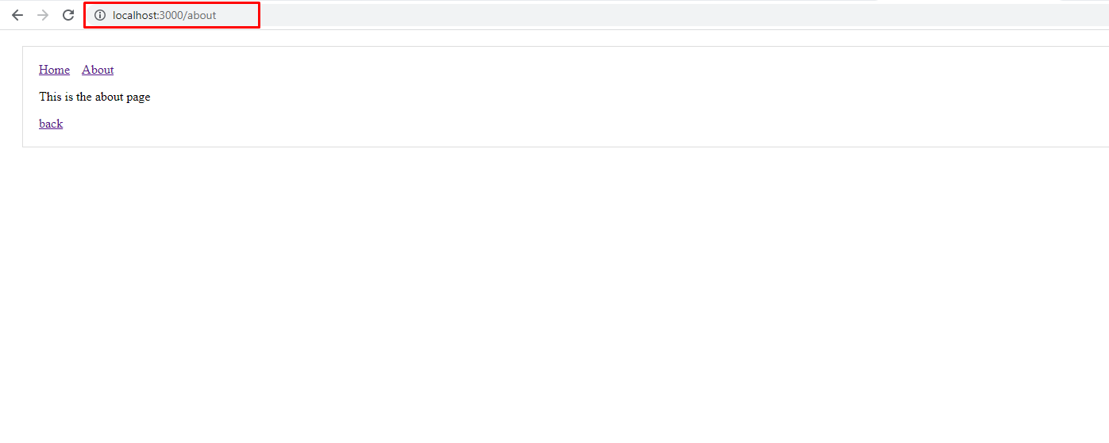

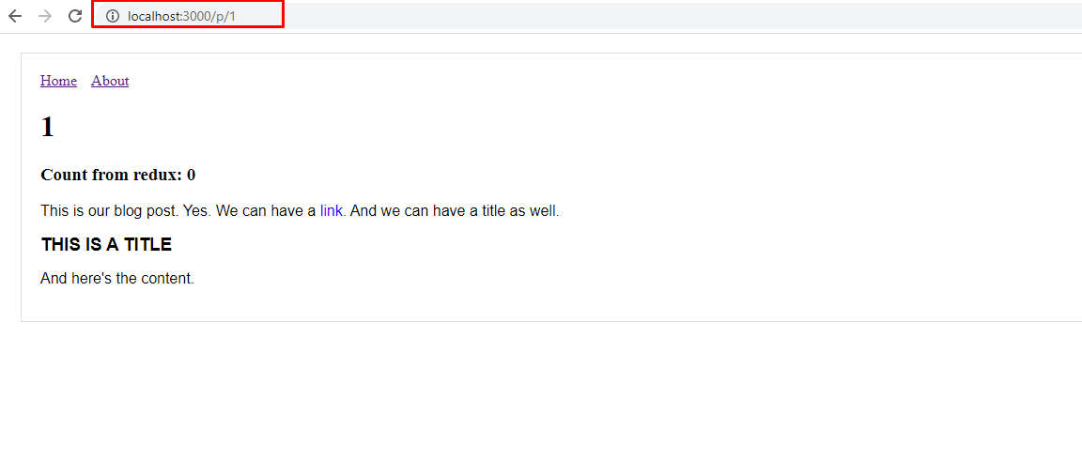

We can use css style files globally from styles directory.

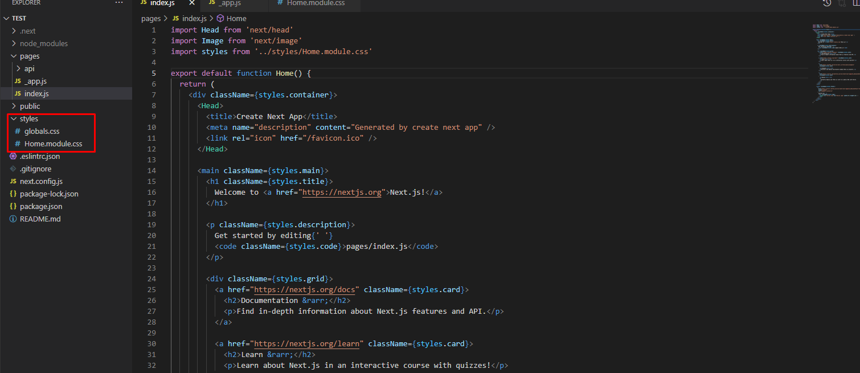

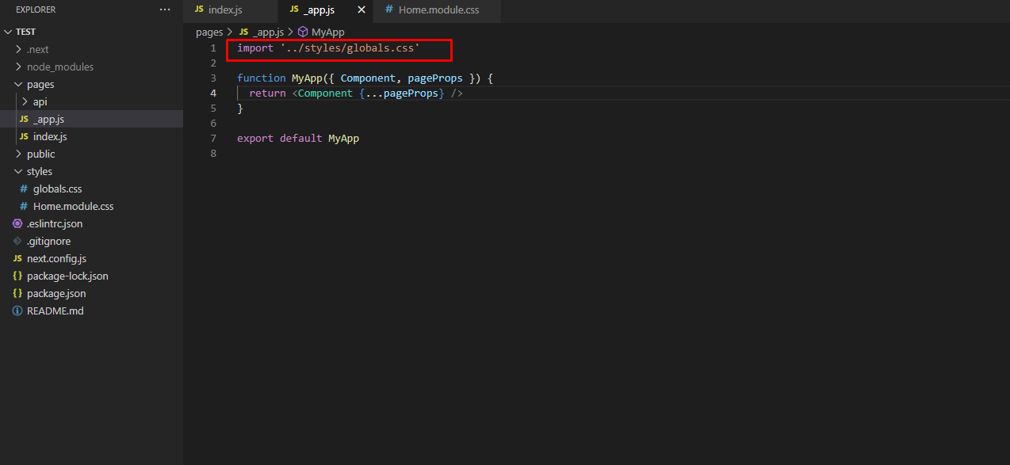

Next.js is React framework so language grammar is the same as React.

In Next.js, we can also connect Redux.

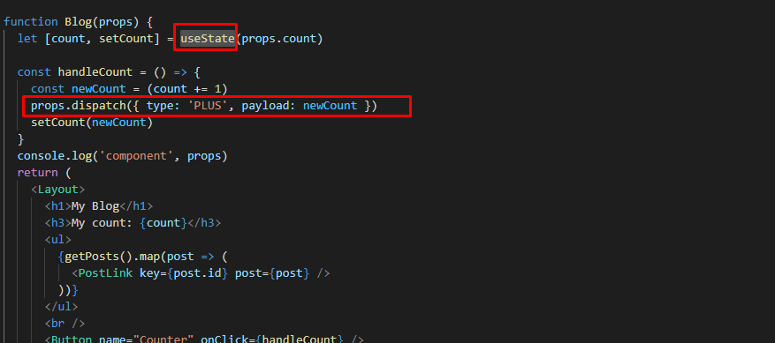

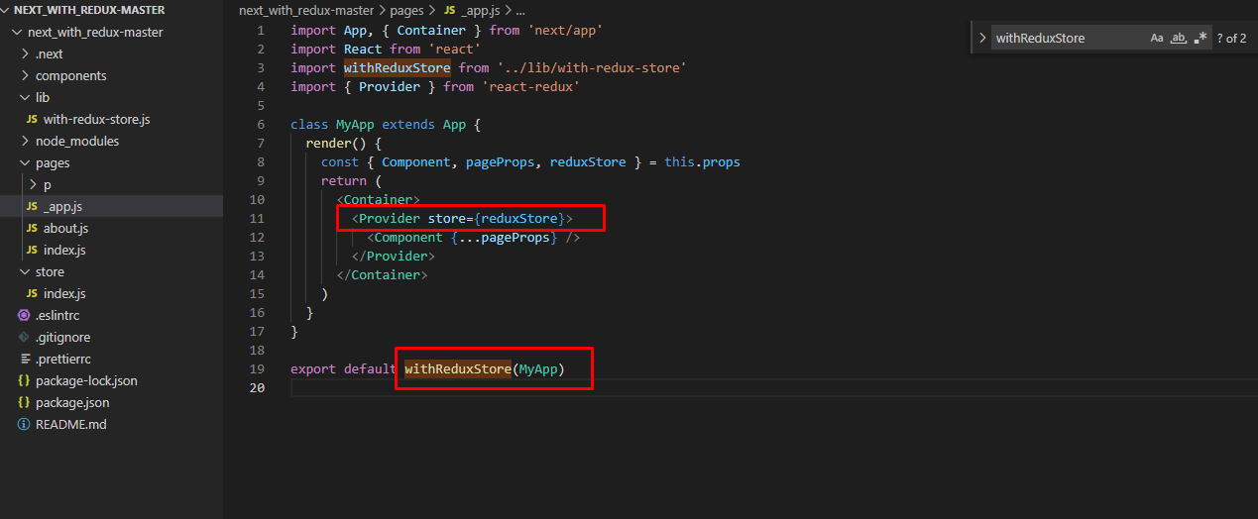

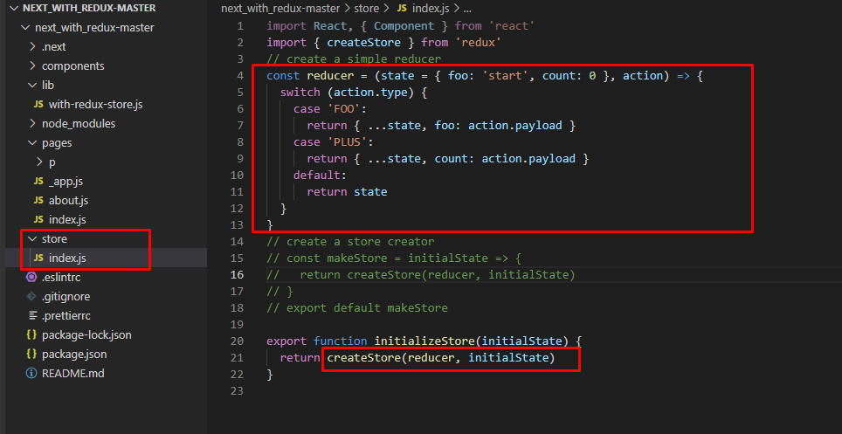

This is a brief summary about Next.js.

In the future, I’d like you to reference more tutorials and videos.

I will give you a sample code for Next.js.

Thank you for reading my document.